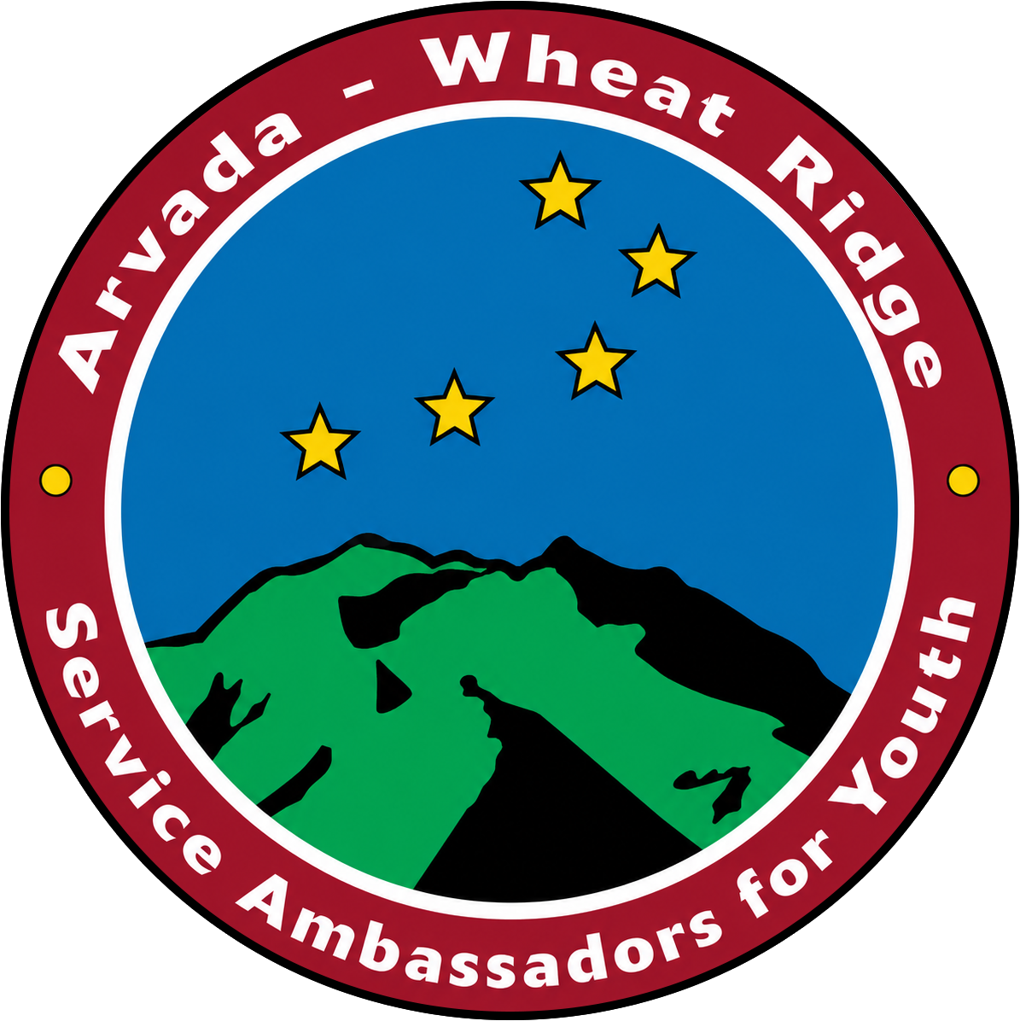
AWRSAY 2026 DONOR FORM
Thank you for supporting Arvada Wheat Ridge Service Ambassadors for Youth (AWRSAY). Your generosity helps recognize young people who have overcome adversity and connects them with scholarships, personal development opportunities, mentorship and a community that believes in their future.
All levels of support are welcome and appreciated.

YOUR SUPPORT
☐ Sponsor a table at the Get it Done Breakfast — $800
☐ Other Donation Amount: $____________________
Total Contribution: $____________________

DONOR INFORMATION
Name: __________________________________________________________
Business/Organization, if applicable: ______________________________________
Address: ________________________________________________________
City/State/ZIP: ___________________________________________________
Email: __________________________________________________________
Phone: __________________________________________________________

RECOGNITION
Please list my/our name as: _______________________________________________
☐ Please recognize my gift anonymously.

PAYMENT
☐ Check enclosed, Check #__________
Make check out to Colorado Gives Foundation and include “AWRSAY DAF” in the memo line.

Please return this form with your check to:
Colorado Gives
5855 Wadsworth Bypass, Unit A
Arvada, CO 80003

